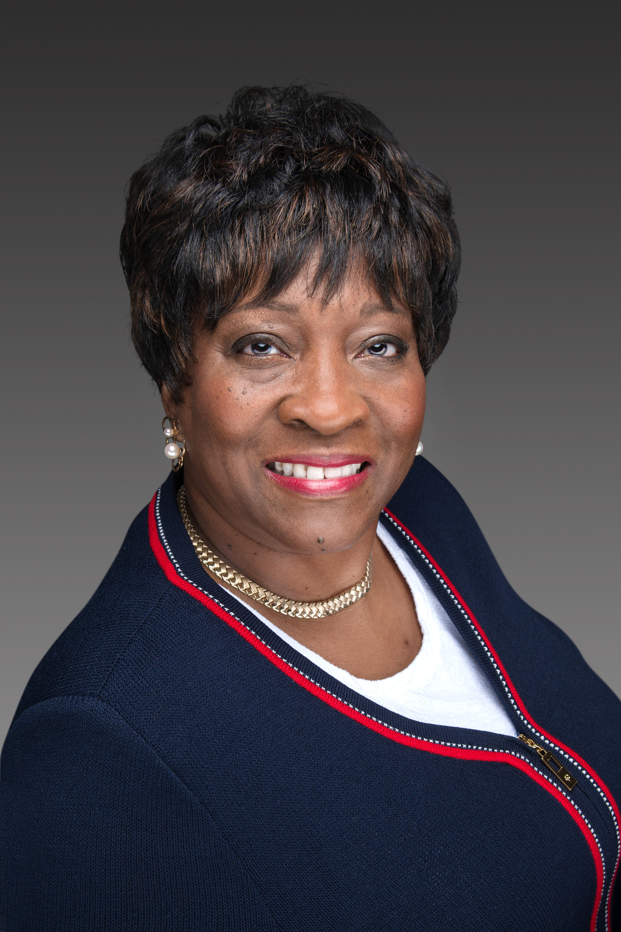
Theresa Harris, President and Founder of TMH Solutions, has more than 30 years of progressively responsible experience in Management and Information Technology. TMH Solutions, LLC is a certified women and minority owned and managed company working to collaborate with her customers and strategic partners to deliver high quality, cost effective solutions.
Prior to establishing TMH Solutions, Theresa was Application Sales Manager for Public Sector for Oracle in the States of Kentucky, Michigan, and Ohio. During her years in the IT field, she’s proven to be a top performer in sales, sales management and professional services with companies such as: Blackwell Consulting Services of Ohio, LLC, Compuware, Computer Associates, Digital Equipment Corporation, Unisys and Xerox. Theresa has led these companies either through start-up, survival, turnaround and growth modes.
Among her significant previous positions, In 2014 Theresa completed the Executive Program at Dartmouth, Tuck School of Business.
Currently, Mrs. Harris serves as an active Board member with Otterbein University, National Association of Business Women Owners (Columbus), the COSI Community Board, Advisory Board member with Per Scholas (Columbus), University of Detroit College of Business Administration Board Advisor, a member of Alpha Kappa Alpha Sorority Incorporated, a 2016 WELD honoree for Women WELDing the Way 2016, a 2017 SMARTWOMEN honoree for Progressive Entrepreneur, a 2019 honoree for the Groundbreaker Diverse Women in Tech Summit, a Columbus Business First 2019 Diversity in Business Award - Outstanding Diversity Champion and 2020 NAWBO Visionary Award recipient.
Previous to this, Theresa held various positions as Board Chair of the Mid-Ohio Food Bank and founder of the Senior African-American Leaders in Technology (The SAALT Group).
Although focused in the information technology field an important aspect of her life is her family. She has been married to Bruno Harris Jr. for 28 years and has a daughter.

